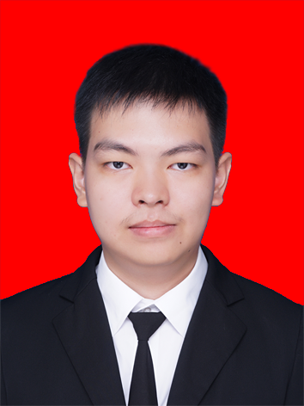
Eric Suwarno

Personal Information
Gender
Male
Birth place and date
Pematangsiantar, 18 October 1994
Current address
Jalan Prof. T. Zulkarnaen no. 9
Kel. Merdeka, Kec. Medan Baru
Medan 20154, Indonesia
E-mail
121402071.es@gmail.com
Telephone / Cellphone
+62 622 21232 / +62 812 6946 2204

Education
- Bachelor of Computer Science, Graduated in July 2017
GPA: 3.55 of 4.0
Faculty of Computer Science and Information Technology, University of Sumatera Utara
- SMA Kristen Kalam Kudus, Pematangsiantar, Indonesia
- SMP Kristen Kalam Kudus, Pematangsiantar, Indonesia
- SD Kristen Kalam Kudus, Pematangsiantar, Indonesia

Qualifications Summary
- Ability to learn new knowledge quickly
- Ability to work in team
- Excellent communication skill
- Focused on detail

Computer Skills
- Experience with both Windows and Macintosh computer
- Proficiency in PHP, Laravel, CodeIgniter, and VB
- Proficiency in MySQL database management

Work Experience
Laboratory Assistant, Information Technology Laboratory Group, University of Sumatera Utara, Medan. October 2014 to January 2017
- Giving practical tutorials of university lessons to the other university students
- Planning the materials that will be given to the students with the lecturer
- Assisting the student in solving problems when working on final assignment

Research Assistant, Department of Information Technology, University of Sumatera Utara, Medan. May 2017 to present
- Managing department data required by lecturers
- Ensure the accuracy of data managed by the department
- Prepare the administration documents required for doing a research

Organizational Experience
- Christian Religion Division Member, HIMATIF (Himpunan Mahasiswa Teknologi Informasi), University of Sumatera Utara (2014 – 2016)
- Head of Production Division, SRC (Software Research Club) USU, 2013 – 2017
- Member of Research Division, SRC (Software Research Club) USU, 2012 – 2013

I hereby declare that the information provided in this document is true and correct.

Sincerely,

Eric Suwarno

